**IFT 466 Advanced Computer Networks**

**Lab 25  
Host Standby Router Protocol (HSRP) – At a glance**

After you complete each step, put a ‘√’ or ‘x’ in the completed box

1. Setting up and configuring the topology

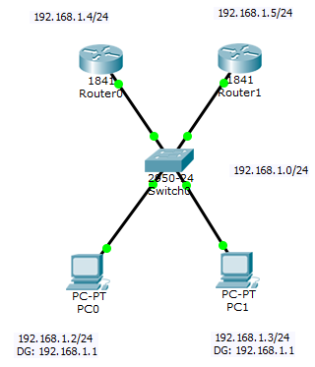

DG on the PCs (192.168.1.1) will the IP address of the virtual router.

Virtual router will be what can be setup as the reliable router.

If either router fails, the virtual router will still be there!

Now all the interfaces are configured, can will now configure HSRP

✓

1. Router 1 configuration

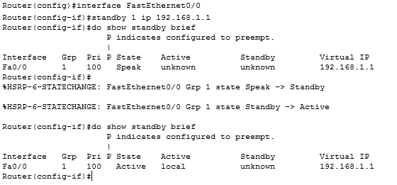

After the configuration we ran the do show standby brief command which shows the router is speaking. Router is learning about the network and becomes active as it is the only router that can become active.

Rerun the same show standby brief command as now we have our active router.

✓

Finally run the do show standby command and see the virtual IP address.

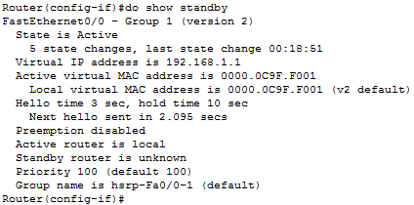

✓

**Question:** What is the standby router?

The Active router is responsible for forwarding the traffic. If it fails, the **Standby router** takes up all the responsibilities of the active router and forwards the traffic.

Router 0 is the only device left standing

1. Router 0 configuration

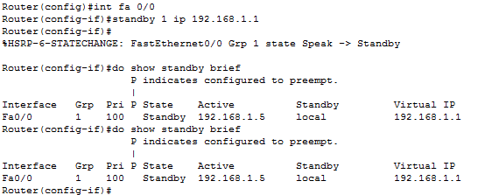

Router 0 is now the standby router.

✓

1. Now we will change R0 to be the active router.   
     
   We will change the priority to 105 and then run the show standby brief command.

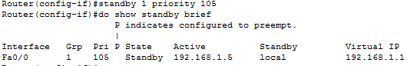

✓

1. Nothing changed, so we will use pre-emption which allow us change the standby router to become the active router



✓

1. Run the show standby brief command again and you will see that this router is now the active router

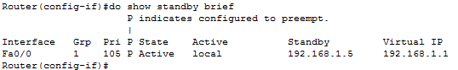

✓

1. Now go back to Router 1 and confirm that is the standby router

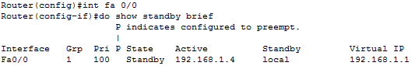

✓

1. Now remove the connection from the switch to R0 (which is currently the active router).

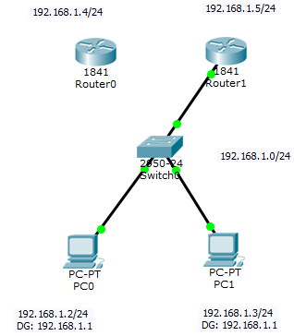

✓

1. Now go into R1 and check the status and without doing anything R1 is now active again



✓

1. Run the show command to verify





